Task 1.1
SELECT *
FROM test_joins_a a, test_joins_b b
WHERE a.id1 > b.id1;
Nested loops were chosen since non-equality condition is being used in joins.
Scanning 10k rows in inner and outer table produces 100,000,000 comparisons and the ones that didn’t satisfy the condition were filtered out.

EXPLAIN ANALYZE
SELECT *
FROM test_joins_a a
CROSS JOIN test_joins_b b;
Hash and Merge joins require a join condition (like a.id1 = b.id1), therefore Nested loop was chosen again. This time no filter, so all 100Mil rows produced

Task 1.2
If we don’t alter the given select query, nested loop is the only viable join approach. If it’s disabled we get
Nested Loop (cost=0.00..
Disabled: true
So nested loop still runs, if it’s the only viable option.
Changing the query to
EXPLAIN ANALYZE
SELECT *
FROM test_joins_a a
JOIN test_joins_b b
ON a.id1 = b.id1;
This, while disabling nestloop and mergejoin
Results into hashjoin
Hash Join (cost=270.00…
Hash Cond: (a.id1 = b.id1)
Semi joins – adding EXISTS (SELECT 1… changes the process of Hash join probing. Value on one end is matched with another single value on probe table and it stops there – no duplicates.
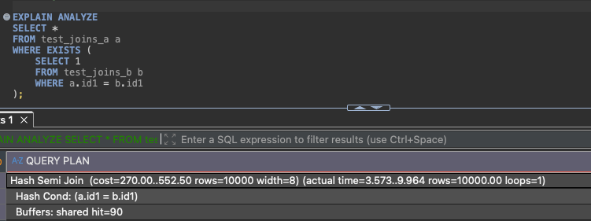
After turning off all 3 methods, it chose Nested Loop.
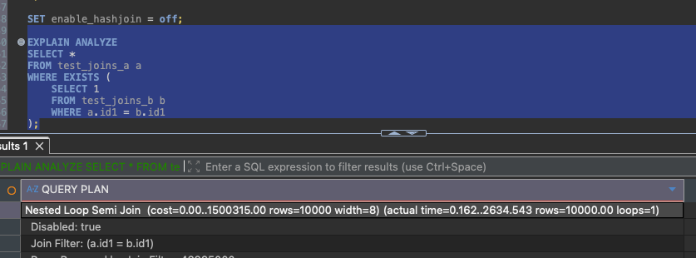
Turning on Hashjoin – we’re back at it.
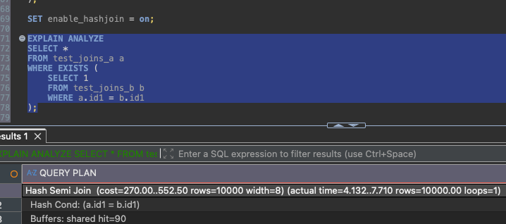
Task 1.3
Sort used and other joins disabled to allow merge join.
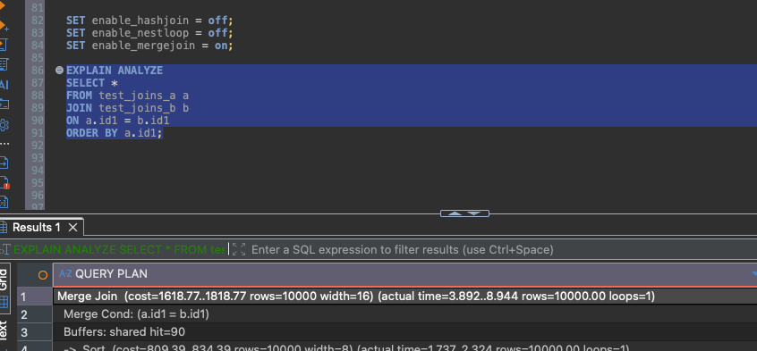
Even though data is ordered, Hashjoin is preferred if given the option.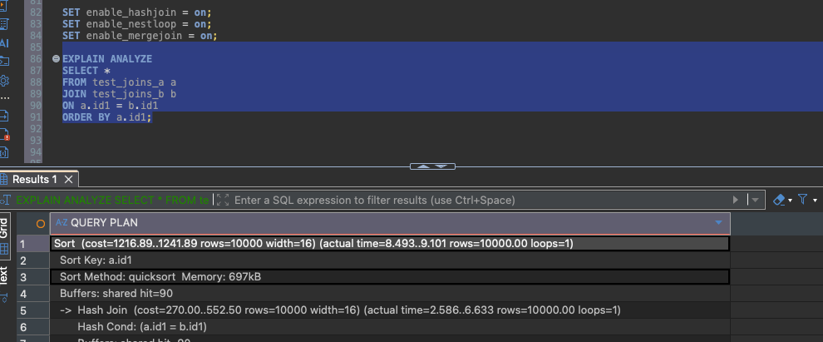

Task 2.1
The actual order of processes in joining is different from what’s written in the script.
What happens first is Seq Scan on test_joins_b, which is hashed and joined with the big table C and finally A.
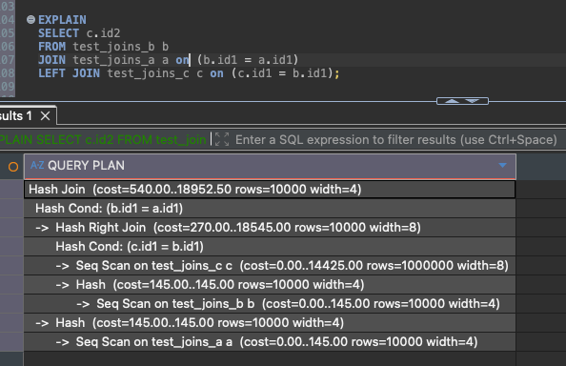

With join_collapse_limit_1, the order of actions changed. A table scanned and joined with B, then joined with C.
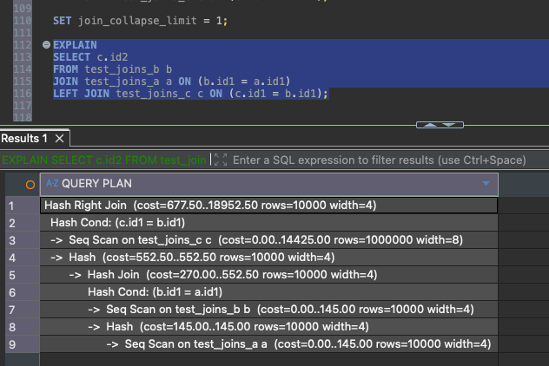
Finally set back to 8, which is the default number of tables postgre is allowed to rearrange when doing joins.

Task 2.2
Lateral join allows to run subquery on each store in this case. We get up to top 10 from the given max order value from each.

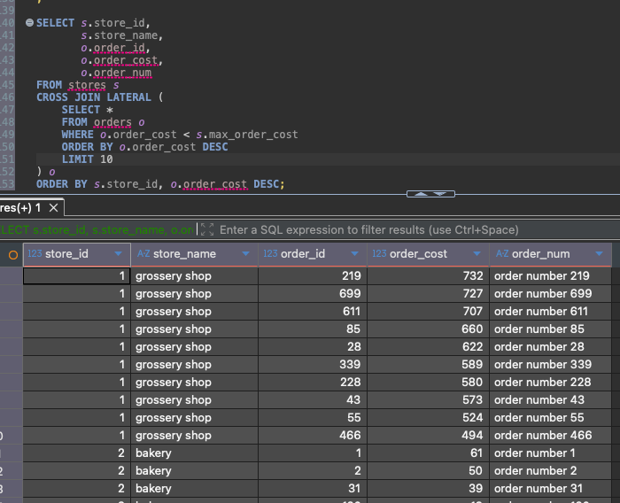
Task 3.1
All queries uploaded too.
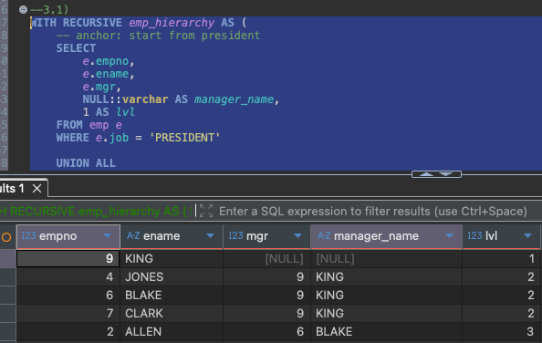

Task 3.2
We got the U and D counts.
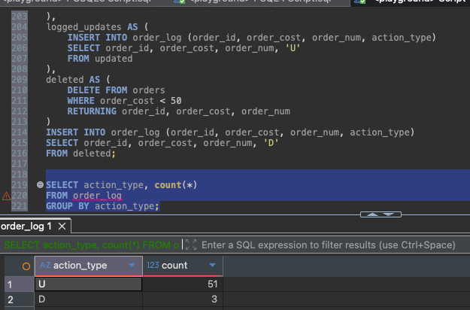
All orders below to deleted indeed.
